Supplemental Materials
The intersecting physical mechanisms that regulate cell viability in 3D synthetic hydrogels
Authors: Nathan R. Richbourg,¹⁻⁴* Akaansha Rampal,¹ Adrian Lorenzana,¹ Juan F. Flechas-Beltran,² Shelly R. Peyton^{1,2}*
¹The University of Massachusetts at Amherst, Amherst, Massachusetts
²Tufts University, Medford, Massachusetts
³FAMU-FSU College of Engineering, Tallahassee, Florida
⁴Florida State University, Tallahassee, Florida
*Co-Corresponding Authors. NRR Email: nrichbourg@eng.famu.fsu.edu SRP Email: shelly.peyton@tufts.edu

DOIs for additional relevant files:
DOI for all protocols and data* used in the manuscript: https://doi.org/10.6084/m9.figshare.c.8040718.v1
*Bulky image data has been removed and is available upon request to the authors.
DOI for the Modular Hydrogel Calculator V3: https://doi.org/10.6084/m9.figshare.30142342.v1
DOI for the Gelation Table: https://doi.org/10.6084/m9.figshare.30142339.v1
DOI for GraphPad Prism files: https://doi.org/10.6084/m9.figshare.30142153.v1
DOI for gelation protocols: https://doi.org/10.6084/m9.figshare.30142126.v1
DOI for peptide preparation protocols: https://doi.org/10.6084/m9.figshare.30142309.v1
DOI for stiffness and swelling protocols: https://doi.org/10.6084/m9.figshare.30142330.v1
DOI for solute transport protocols: https://doi.org/10.6084/m9.figshare.30142324.v1
DOI for cell response protocols: https://doi.org/10.6084/m9.figshare.30142066.v1
DOI for gel synthesis data: https://doi.org/10.6084/m9.figshare.30142093.v1
DOI for mechanics, swelling, and degradation data: https://doi.org/10.6084/m9.figshare.30142162.v1
DOI for transwell transport data: https://doi.org/10.6084/m9.figshare.30142336.v1
DOI for FRAP data: https://doi.org/10.6084/m9.figshare.30142081.v1
DOI for 2D cell culture data: https://doi.org/10.6084/m9.figshare.30142021.v1
DOI for 3D cell culture data: https://doi.org/10.6084/m9.figshare.30142045.v1
DOI for cell tracking, distribution, and size analysis data: https://doi.org/10.6084/m9.figshare.30142069.v1
DOI for PEG-NB gel characterization data: https://doi.org/10.6084/m9.figshare.30142303.v1

Supplementary Table ST1: Gel formulations used in figures.
Fig. | Sub-Identifier | End- Group | Total Poly. Vol. Frac. (%) | PEG Type | X-Linking Ratio | IBP Conc. (mM) | IBP Type | PCP Frac. (%) | PCP Type | Solution | Encapsulated Cells
1a | N/A | MAL | 10 | 4A10K | Unsat. | 2 | FITC-DGEA | 0 | N/A | PBS, pH 7.4 | N/A
1b | N/A | VS | 10 | 4A10K | Unsat. | 2 | FITC-DGEA | 0 | N/A | HEPES, pH 7.4 | N/A
1c | N/A | MAL | 10 | 4A10K | Unsat. | 2 | Rhod-GPR | 0 | N/A | PBS, pH 7.4 | N/A
1d | N/A | VS | 10 | 8A20K | Unsat. | 0 | N/A | 0 | N/A | HEPES, pH 7.4 | N/A
1e | N/A | VS | 10 | 4A20K | Unsat. | 0 | n/A | 0 | N/A | HEPES, pH 7.4 | N/A
1f | N/A | VS | 10 | 8A20K | Unsat. | 2 | RGD | 25 | Pan | HEPES, pH 7.4, Media | HCC-1954
1g | N/A | VS | 10 | 4A20K | Unsat. | 2 | RGD | 25 | Pan | HEPES, pH 7.4, Media | HCC-1954
1h | N/A | MAL | 10 | 4A20K | Unsat. | 2 | RGD | 25 | Pan | PBS, pH 7.4, Media | HCC-1954
1i | Matrigel* | N/A | N/A | N/A | N/A | N/A | N/A | N/A | N/A | Matrigel, Media | HCC-1954
2a | N/A | VA | 10 | 4A20K | Unsat | 2 | RGD | 25 | Pan | HEPES, pH 7.0-7.9 | N/A
2b | No Peptide | VS | 10 | 4A20K | Unsat. | 0 | N/A | 0 | N/A | HEPES, pH 7.0-7.9  (9 versions) | N/A
2b | RGD | VS | 10 | 4A20K | Unsat. | 2 | RGD | 0 | N/A | HEPES, pH 7.0-7.9  (9 versions) | N/A
2b | Pan | VS | 10 | 4A20K | Unsat. | 0 | N/A | 25 | Pan | HEPES, pH 7.0-7.9  (9 versions) | N/A
2b | RGD+Pan | VS | 10 | 4A20K | Unsat. | 2 | RGD | 25 | Pan | HEPES, pH 7.0-7.9  (9 versions) | N/A
2c | RGD-Pan | VA | 10 | 4A20K | Unsat | 2 | RGD | 25 | Pan | HEPES, pH 7.8 | N/A
2c | PHSRN-Pan | VS | 10 | 4A20K | Unsat. | 2 | PHSRN | 25 | Pan | HEPES, pH 7.8 | N/A
2c | DGEA-Pan | VS | 10 | 4A20K | Unsat. | 2 | DGEA | 25 | Pan | HEPES, pH 7.8 | N/A
2c | GPR-Pan | VS | 10 | 4A20K | Unsat. | 2 | GPR | 25 | Pan | HEPES, pH 7.8 | N/A
2c | YIGSR-Pan | VS | 10 | 4A20K | Unsat. | 2 | YIGSR | 25 | Pan | HEPES, pH 7.8 | N/A
2c | RGD-MMP1 | VA | 10 | 4A20K | Unsat | 2 | RGD | 25 | MMP1 | HEPES, pH 7.8 | N/A
2c | RGD-MMP2 | VS | 10 | 4A20K | Unsat. | 2 | RGD | 25 | MMP2 | HEPES, pH 7.8 | N/A
2c | Bone V. 1.5 | VS | 10 | 4A20K | Unsat. | 2 | Bone V. 1.5 | 25 | MMP1/2 | HEPES, pH 7.8 | N/A
2c | Lung V. 1.5 | VS | 10 | 4A20K | Unsat. | 2 | Lung V. 1.5 | 25 | MMP1/2 | HEPES, pH 7.8 | N/A
2c | Brain V. 1.5 | VS | 10 | 4A20K | Unsat. | 2 | Brain V. 1.5 | 25 | MMP2 | HEPES, pH 7.8 | N/A
3a | 4A10K Ideal | VS | 10 | 4A10K | Ideal | 0 | N/A | 0 | N/A | HEPES, pH 7.4 | N/A
3a | 4A10K Unsat. | VS | 10 | 4A10K | Unsat. | 0 | N/A | 0 | N/A | HEPES, pH 7.4 | N/A
3a | 4A10K RGD-Pan | VS | 10 | 4A10K | Unsat. | 2 | RGD | 25 | Pan | HEPES, pH 7.4 | N/A
3a | 8A20K Ideal | VS | 10 | 8A20K | Ideal | 0 | N/A | 0 | N/A | HEPES, pH 7.4 | N/A
3a | 8A20K Unsat. | VS | 10 | 8A20K | Unsat. | 0 | N/A | 0 | N/A | HEPES, pH 7.4 | N/A
3a | 8A20K RGD-Pan | VS | 10 | 8A20K | Unsat. | 2 | RGD | 25 | Pan | HEPES, pH 7.4 | N/A
3b | 4A20K Ideal | VS | 10 | 4A20K | Ideal | 0 | N/A | 0 | N/A | HEPES, pH 7.4 | N/A
3b | 4A20K Unsat. | VS | 10 | 4A20K | Unsat. | 0 | N/A | 0 | N/A | HEPES, pH 7.4 | N/A
3b | 4A20K RGD-Pan | VS | 10 | 4A20K | Unsat. | 2 | RGD | 25 | Pan | HEPES, pH 7.4 | N/A
3b | Matrigel* | N/A | N/A | N/A | N/A | N/A | N/A | N/A | N/A | Matrigel | N/A
3c | Matrigel* | N/A | N/A | N/A | N/A | N/A | N/A | N/A | N/A | Matrigel, Media | HCC-1954
3c | PEG Gel | VS | 10 | 4A20K | Unsat. | 2 | RGD | 25 | Pan | HEPES, pH 7.8, Media | HCC-1954
3d | 0 mM RGD | VS | 10 | 8A20K | Half | 0 | N/A | 0 | N/A | HEPES, pH 7.8 | HCC-1954
3d | 2 mM RGD | VS | 10 | 8A20K | Half | 2 | RGD | 0 | N/A | HEPES, pH 7.8 | HCC-1954
3d | 5 mM RGD | VS | 10 | 8A20K | Half | 5 | RGD | 0 | N/A | HEPES, pH 7.8 | HCC-1954
3d | 10 mM RGD | VS | 10 | 8A20K | Half | 10 | RGD | 0 | N/A | HEPES, pH 7.8 | HCC-1954
3e | 2 mM, 25% | VS | 10 | 8A20K | Half | 2 | RGD | 25 | Pan | HEPES, pH 7.8, Media | HCC-1954
3e | 2 mM, 75% | VS | 10 | 8A20K | Half | 2 | RGD | 75 | Pan | HEPES, pH 7.8, Media | HCC-1954
3e | 10 mM, 25% | VS | 10 | 8A20K | Half | 10 | RGD | 25 | Pan | HEPES, pH 7.8, Media | HCC-1954
3e | 10 mM, 75% | VS | 10 | 8A20K | Half | 10 | RGD | 75 | Pan | HEPES, pH 7.8, Media | HCC-1954
3f-h | 8A20K-HX, 0% | VS | 10 | 8A20K | Half | 0 | N/A | 0 | N/A | HEPES, pH 7.8 | N/A
3f-h | 8A20K-HX, 25% | VS | 10 | 8A20K | Half | 0 | N/A | 0 | N/A | HEPES, pH 7.8 | N/A
3f-h | 8A20K-HX, 50% | VS | 10 | 8A20K | Half | 0 | N/A | 0 | N/A | HEPES, pH 7.8 | N/A
3f-h | 8A20K-HX, 75% | VS | 10 | 8A20K | Half | 0 | N/A | 0 | N/A | HEPES, pH 7.8 | N/A
3f-h | 4A10K | VS | 10 | 4A10K | Unsat. | 0 | N/A | 0 | N/A | HEPES, pH 7.8 | N/A
3f-h | 8A20K | VS | 10 | 8A20K | Unsat. | 0 | N/A | 0 | N/A | HEPES, pH 7.8 | N/A
3f-h | 4A20K | VS | 10 | 4A20K | Unsat. | 0 | N/A | 0 | N/A | HEPES, pH 7.8 | N/A
4b-e | TG | VS | 10 | 8A20K | Half | 0 | N/A | 0 | N/A | HEPES, pH 7.8 | HCC-1954
4b-e | SUB | VS | 10 | 8A20K | Half | 10 | RGD | 0 | N/A | HEPES, pH 7.8 | HCC-1954
4f | N/A | VS | 10 | 8A20K | Half | 10 | RGD | 25 | Pan | HEPES, pH 7.8 | HCC-1954
4h-k | 8A20K-HX | VS | 10 | 8A20K | Half | 0 | N/A | 0 | N/A | HEPES, pH 7.8 | N/A
4h-k | 4A10K | VS | 10 | 4A10K | Unsat. | 0 | N/A | 0 | N/A | HEPES, pH 7.8 | N/A
4h-k | 4A20K | VS | 10 | 4A20K | Unsat. | 0 | N/A | 0 | N/A | HEPES, pH 7.8 | N/A
4h-k | Matrigel* | N/A | N/A | N/A | N/A | N/A | N/A | N/A | N/A | Matrigel | N/A
5a-f | N/A | VS | 10 | 8A20K | Half | 10 | RGD | 75 | Pan | HEPES, pH 7.8, Media | HS-5, NIH-3T3, HCC-1954, MDA-MB-231
5g,h | 6% PVF 25% Deg | VS | 6 | 8A20K | Half | 10 | RGD | 25 | Pan | HEPES, pH 8.5, Media | HCC-1954
5g,h | 10% PVF 25% Deg | VS | 10 | 8A20K | Half | 10 | RGD | 25 | Pan | HEPES, pH 7.8, Media | HCC-1954
5g,h | 10% PVF 75% Deg | VS | 10 | 8A20K | Half | 10 | RGD | 75 | Pan | HEPES, pH 7.8, Media | HCC-1954
5g,h | Matrigel* | N/A | N/A | N/A | N/A | N/A | N/A | N/A | N/A | Matrigel, Media | HCC-1954
*Matrigel was used as-purchased without dilution from Corning Matrigel Basement Membrane Matrix Cat. No. 354234, Lot #3033001 at protein concentration 8.2 mg/mL
IBP: integrin-binding peptide. PCP: Protease-cleavable peptide
HEPES was always used at 50 mM, PBS at 1x PBS.
Gels with cells inside included trace amounts of the cells’ media (RPMI-1640 for HCC-1954s, DMEM for HS-5s, NIH-3T3s, and MDA-MB-231s).
Bone V. 1.5: 55.6% RGD, 20.4% PHSRN, 5.6% DGEA, 14.8% GPR, 3.7% YIGSR
Lung V. 1.5: 70.7% RGD, 19% GPR, 10.3% PHSRN
Brain V. 1.5: 50% RGD, 34.2% DGEA, 15.8% YIGSR

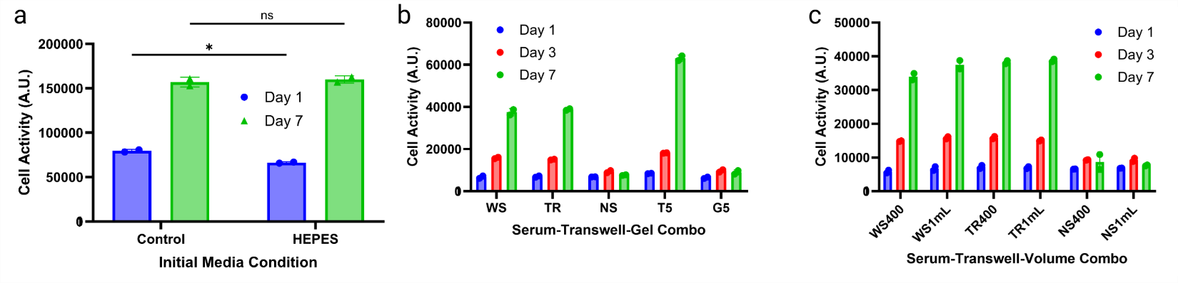
Supplementary Figure S1. Additional quantifications of cell-gel interactions.
a, Cell growth following a one-hour incubation in HEPES was non-significantly different from a control group on day 7. b, Cells cultured with a transwell where serum was in both the main well and transwell grew normally (TR), whereas cells where serum was only in the transwell at a 5x concentration grew excessively (T5), but if there was a gel barrier in the transwell, cells did not grow despite the 5x serum concentration (G5). c, Likewise, cell ATP activity was insensitive to any oxygen restriction by adding or removing a transwell or increasing the media volume from 400 μL to 1 mL to negate the hydrostatic pressure difference between the transwell and the main well.

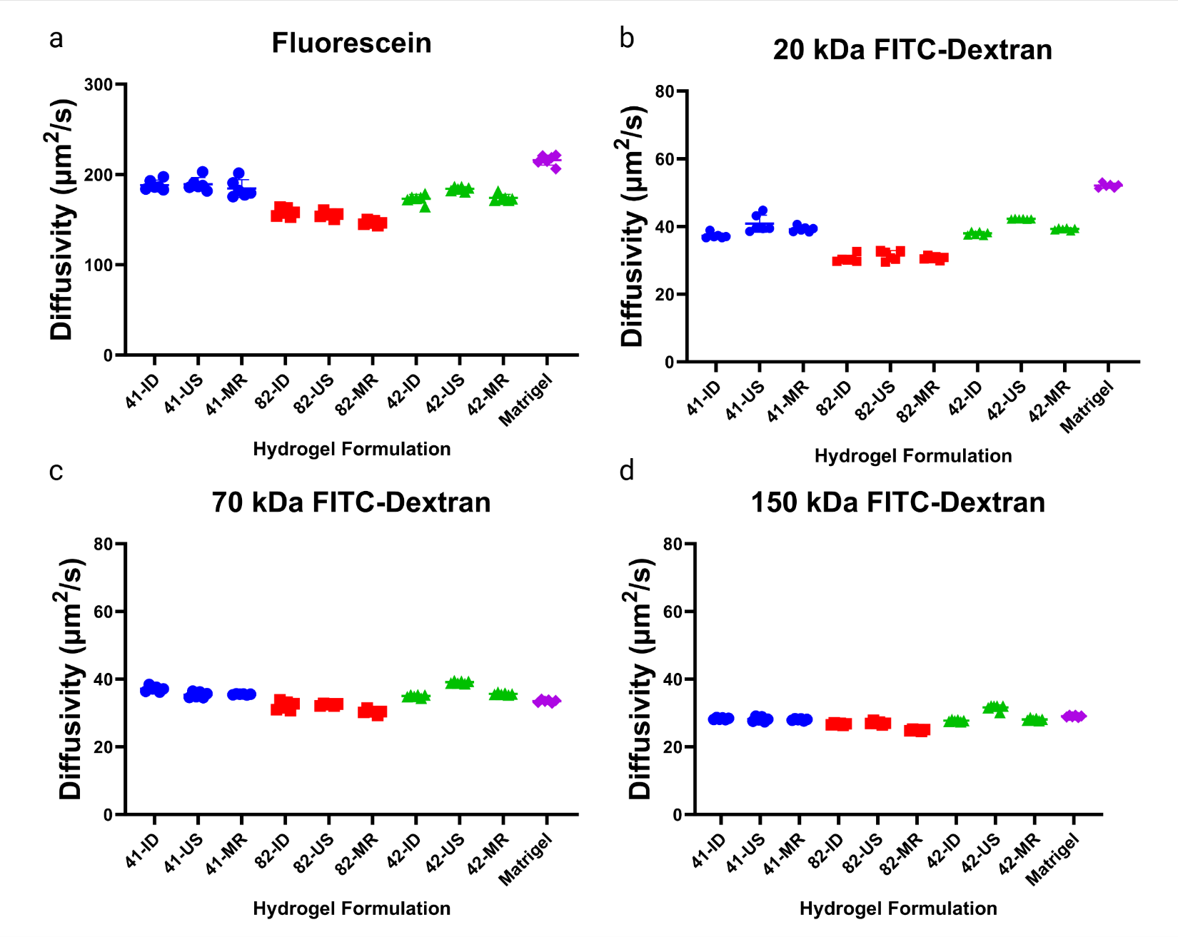
Supplementary Figure S2: FRAP in hydrogels.
a-d, FRAP-measured diffusion coefficients of solutes in 9 PEG-VS hydrogel formulations and Matrigel. 4-arm 10kDa (41), 4-arm 20 kDa (42), and 8-arm 20 kDa (82) with either ideal (ID), unsaturated (US), or MMP & RGD-included (MR) crosslinking.
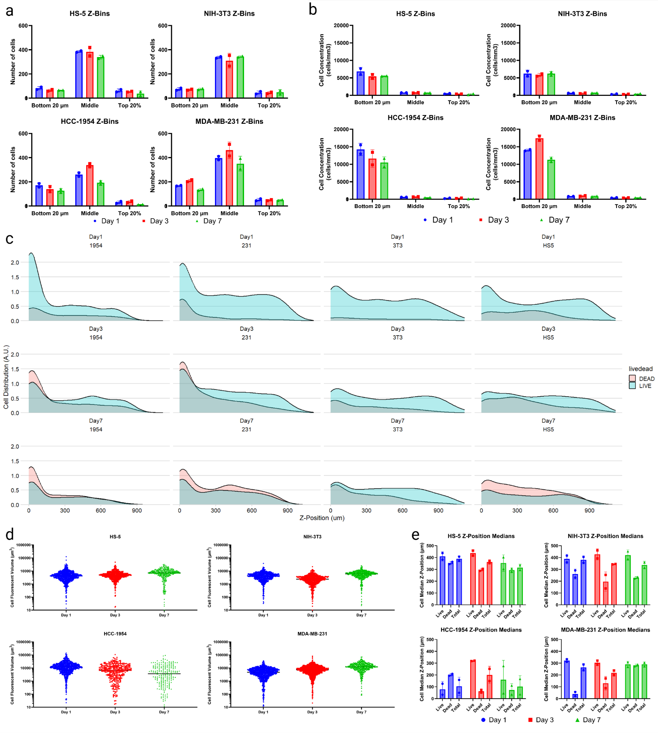
Supplementary Figure S3: Quantitative analysis of cell distributions in 3D PEG-VS hydrogels.
a,b, Cell distributions were assessed by binning based on z-position to assess regional trends, including total number of cells (a) and cell concentrations (b). c, Continuous histograms of cell z-distributions for each cell type and time point. d, Cell volumes assessed over time for each cell type using Surfaces in Imaris. e, Cell z-position medians to assess biases in live and dead cell locations.
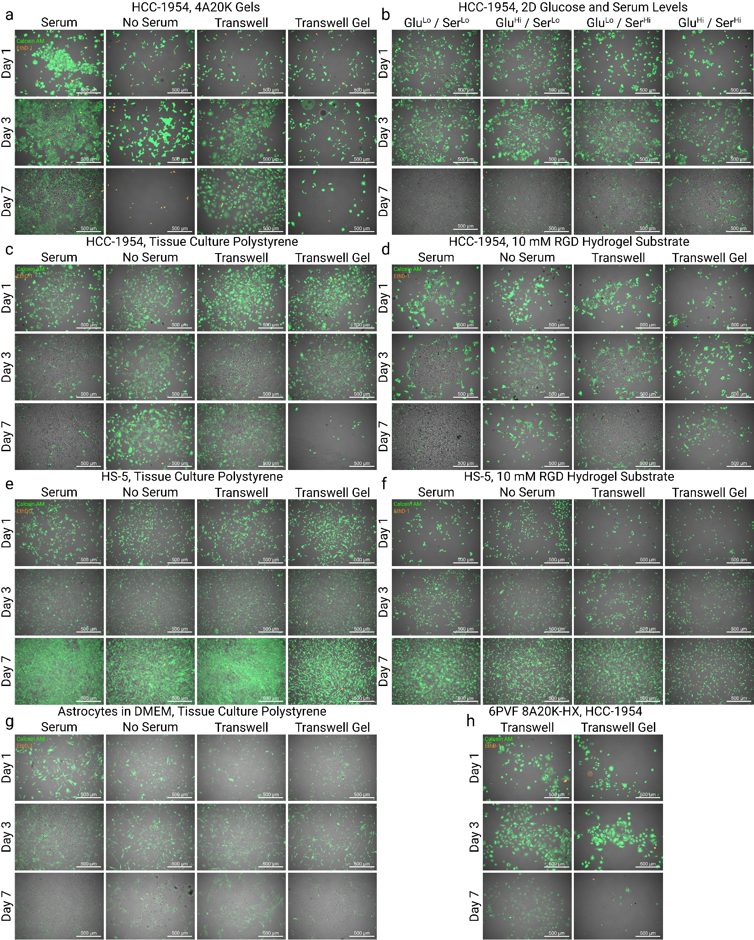
Supplementary Figure S4: Representative live/dead images in 2D culture conditions.
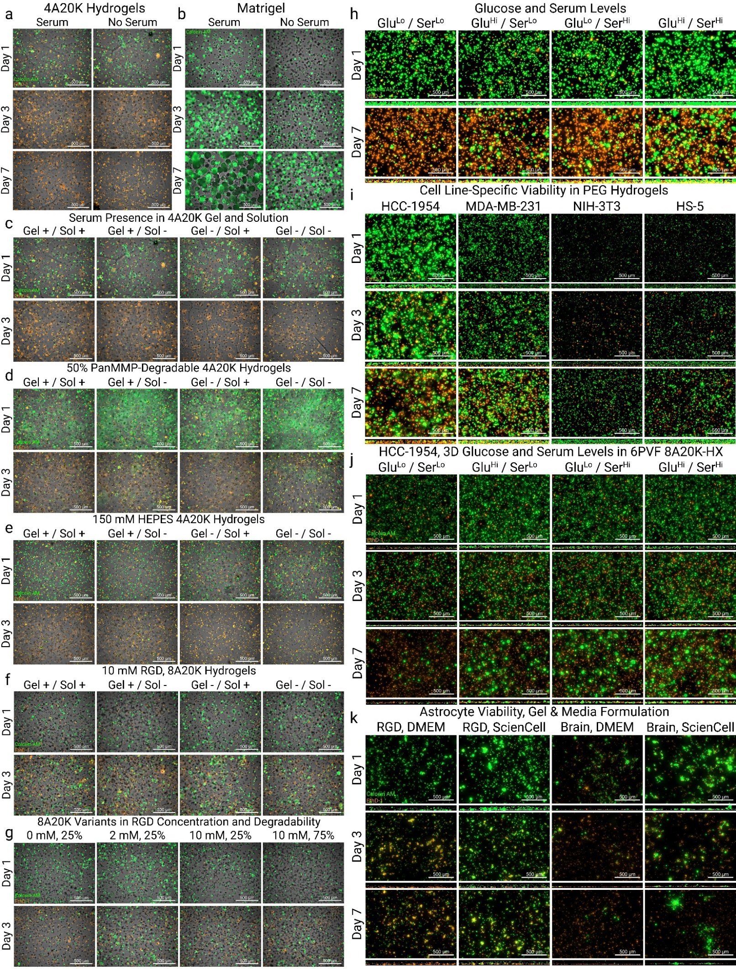
Supplementary Figure S5: Representative live/dead images and orthogonal projections of cells in 3D.
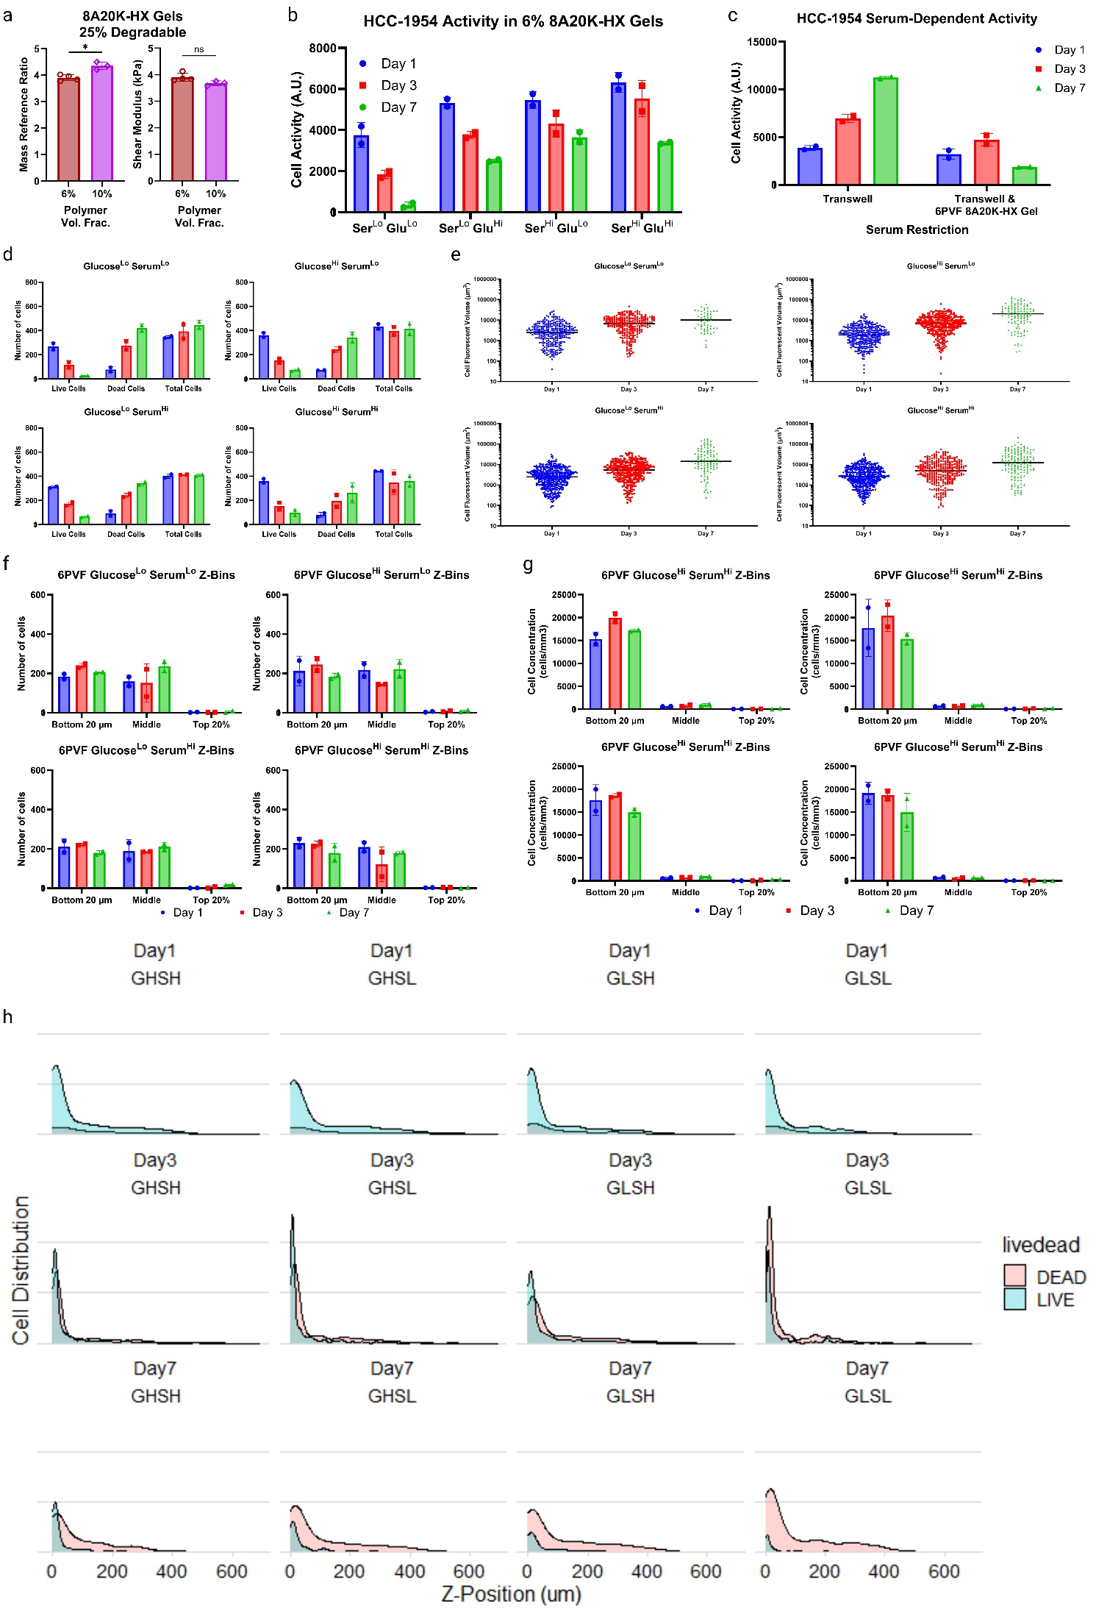
Supplementary Figure S6: Analysis of HCC-1954 Cell Responses to 6% vol/vol 8A20K-HX gels with 10 mM RGD and 25% degradable crosslinks.
a, Comparison of swelling and stiffness for 6% and 10% 8A20K-HX Peg-VS hydrogels. b, Serum- and glucose-dependent cell ATP activity in 6% hydrogels. c, Cell ATP activity when serum is restricted by 6% hydrogels. d, Live, dead, and total cell counts over time in 6% hydrogels. e, Cell area over time in 6% hydrogels. f,g, Z-binned cell numbers and cell concentrations in 6% hydrogels. h, Continuous z-distributions of cells in 6% hydrogels.

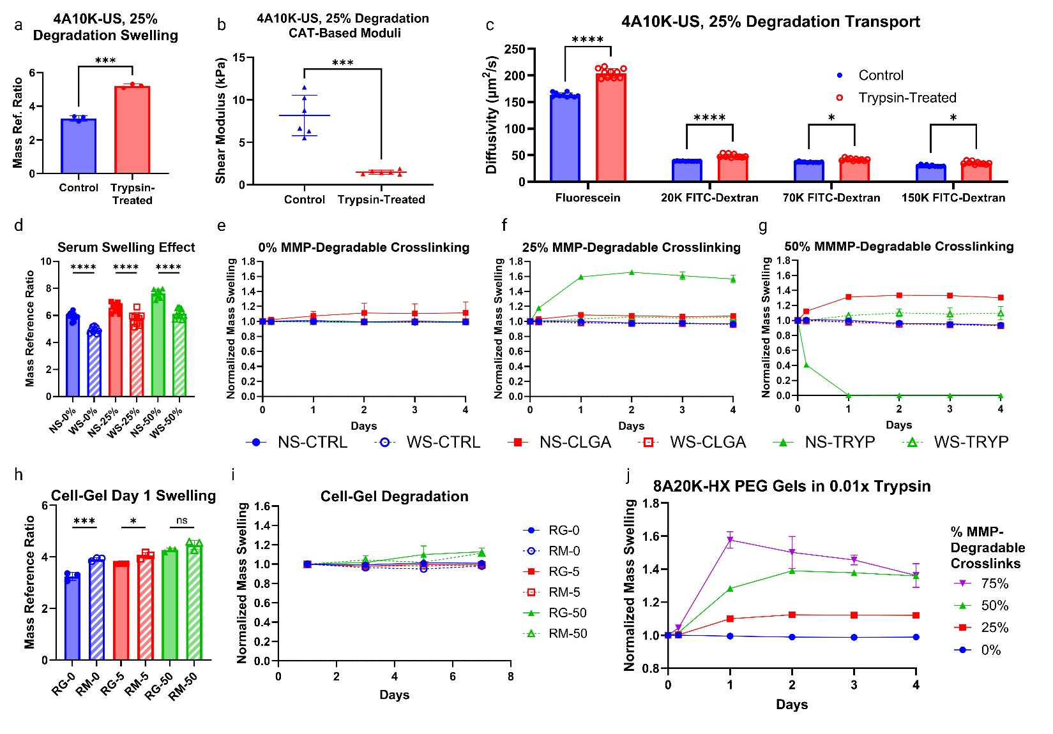
Supplementary Figure S7: Characterization of enzymatic gel degradation using trypsin.
a,b,c, How high-concentration trypsin (0.1x) degradation for 24 hours affects the swelling (a), stiffness (b), and FRAP-based solute transport profile (c) of a 25% degradable 4-arm, 10 kDa PEG hydrogel. d-g, Serum incorporation (WS vs NS) affects the initial swelling (d) and negates degradation over time of 0% (e), 25% (f), and 50% (g) degradable hydrogels. 1xPBS without enzymes (CTRL), 0.01x trypsin (TRYP), and 0.001 mg/mL collagenase (CLGA), replaced daily, was used for e-g. Moderate degradation resulted in increased swelling, whereas extensive degradation fully eroded the gel (NS-TRYP in f vs. g). h,i, Cell-driven degradation was negligible over 7 days, partially due to extensive cell death. j, The 25-75% degradable 8A20K-HX PEG-VS gels swelled substantially, with mass loss over days 1-4 in the 75% degradable gel, which is likely due to partial loss of the original polymer due to degradation.

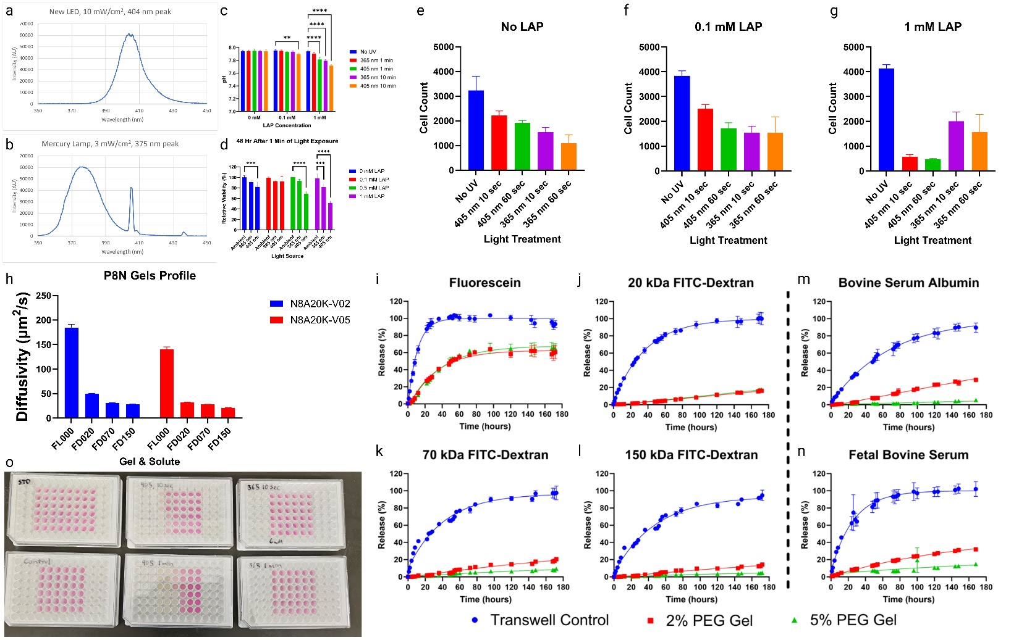
Supplementary Figure S8: PEG-Norbornene gel and photoinitiator characterization.
a,b Light spectra for an LED UV source (a) and a mercury lamp (b) used to photoinitiate PEG-norbornene gels. c, effect of light source, exposure time, and LAP concentration on the pH of RPMI 1640 media. 365 nm is the mercury lamp, and 405 nm is the LED source. Both sources were held at an appropriate distance to transmit 3 mW/cm² intensity. d, Relative HCC-1954 cell viability (CellTiter-Glo 2.0 ATP activity assay, normalized to untreated cells) 48 hours after 1 min of UV light exposure at varying concentrations of LAP in media. e,f,g, Cell counts using CellTiter-Glo 2.0 and a standard curve from seeded cells, used to assess cell responses three days after UV and LAP treatments. h, fluorescent solute diffusion coefficients for fluorescein and 20, 60, and 150 kDa FITC-dextran in 2% v/v and 5% v/v 8-arm, 20 kDa PEG-Norbornene gels. i-n, Solute transport over time through transwells or transwells coated with 100 μL of 2% or 5% PEG-Norbornene gels over 7 days. o, Visual representations of the change in media color due to phenol red reactions with radicals following LAP exposure to UV light sources. Each plate presents decreasing LAP concentrations from left to right, with serum in the top three rows and no serum in the bottom three rows.

